ZVS driver, induction heater

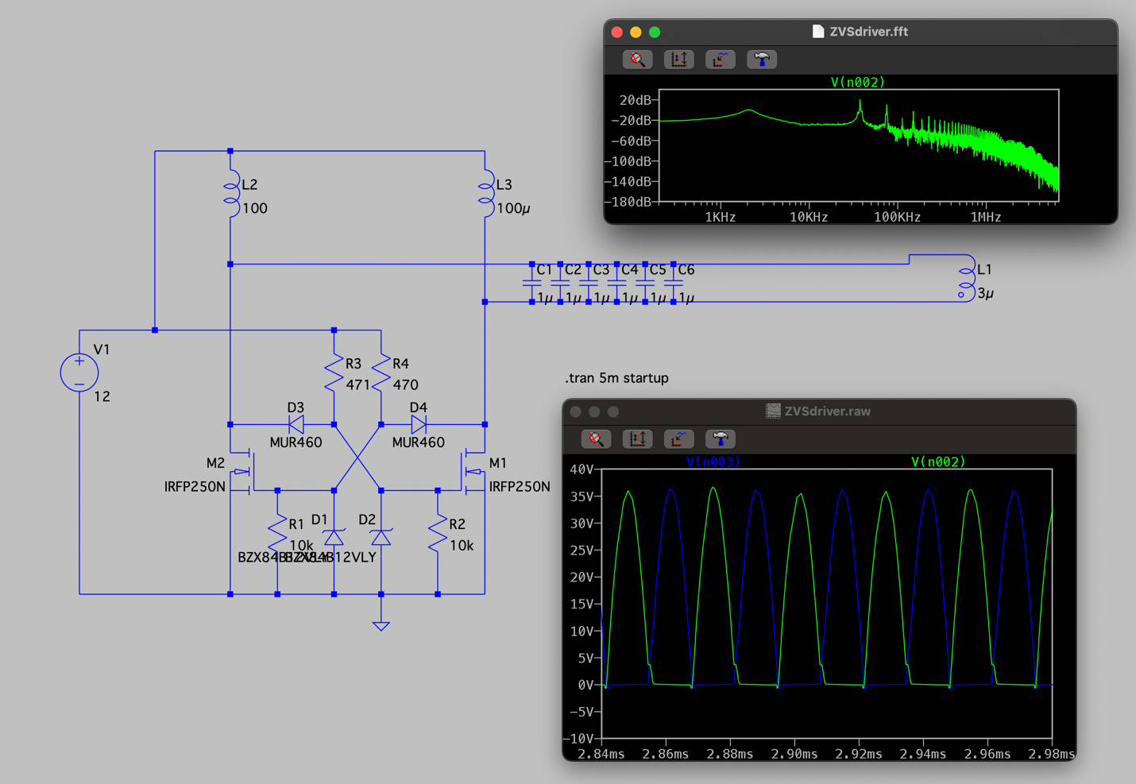
B.O.M
- L2 and L3 –100uH 20A toroidal inductors
- D3 and D4 – UF4007 ultrafast diodes (in schematic there are analog MUR460s)
- R3 and R4 – 470R 1W resistors
- C1-C6 – MKP10 polipropelyne capacitors 1uF
- L1- air wound coil 10awg wire, 5cm diameter 8-10 turns, 2-3uH
- M1 and M2 – IRFP250N NMOSFET
- R1 and R2 – 10k 1W resistors
- D1 and D2 – 12v zener diodes.
- V1 – 12v power supply (car battery, PSU, etc.)

Output signals

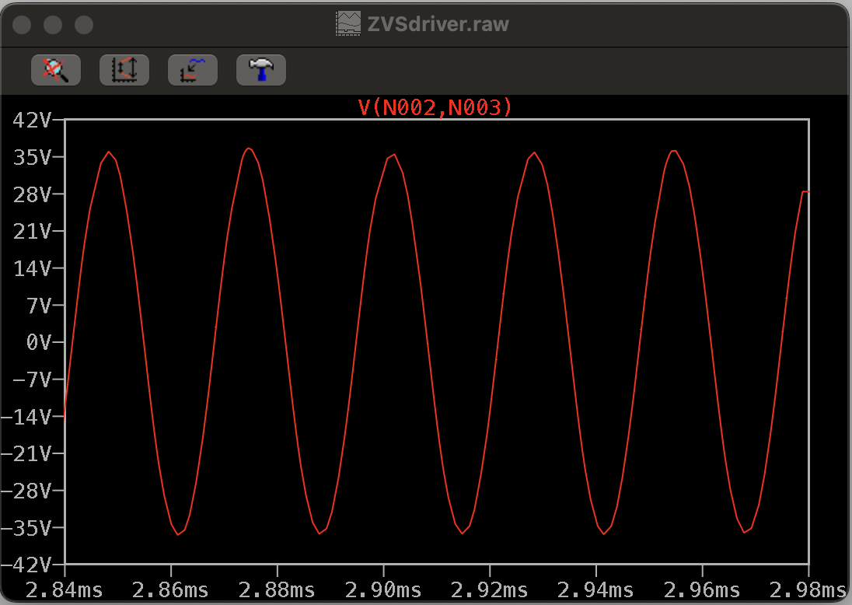

Output signal is the AC voltage running through the L1 coil that heats the metal

Main parameters
- Input voltage – 12v
- Current while not heating anything – 1-1.5A. Current while heating – up to 20A
- Working frequency
- Efficiency η=~90%

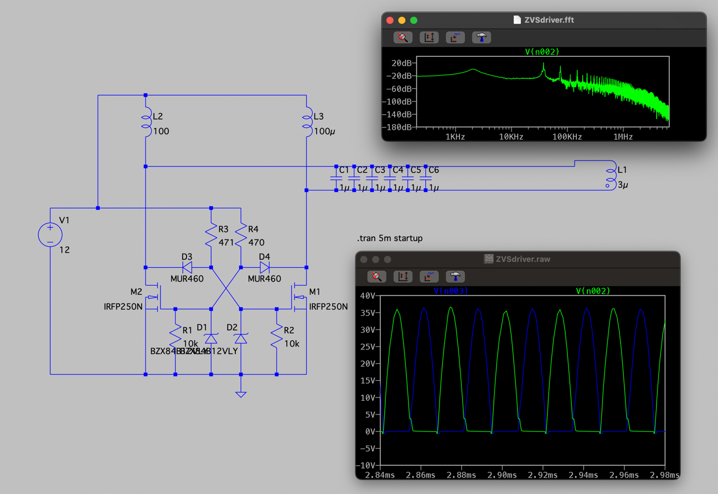
Components explained

- L2 and L3 are there to lower the startup current and separate the low 12V supply voltage from the ~36V peaks so the power supply doesn't get fried (inductor choke). I used 100uH inductors for each side.
- V1 is just a PC power supply (12V). You could use a car battery too, but I went with a PSU because it has built-in overcurrent protection.
- C1 through C6 and L1 make up the parallel resonant circuit. This part stores energy and boosts the current up to 40A, even when the power supply is only putting out 2 to 20A. The capacitors form a 6uF bank. I used six of them in parallel to spread out the high current. They are MKP10 polypropylene capacitors made for high frequencies. The L1 coil is made from 10awg 6mm2 wire. Ideally, I’d use copper tubing with water cooling, but I stuck with wire because it's simpler and cheaper.
- D3 and D4 are UltraFast diodes. They switch on the NMOSFET on the opposite side when the cathode voltage jumps from 0V to around 36V. I picked these because they have a really low reverse recovery time of about 75ns and can handle high voltage.
- D1 and D2 are 12V Zener diodes. Their job is to limit the NMOSFET gate voltage to 12V so it doesn't get overloaded.
- R3 and R4 are 470 ohm resistors that limit the current flowing into the NMOSFET gates.
- R1 and R2 are 10k pull-down resistors. They make sure there is no leftover charge on the gate so the NMOSFET doesn't stay halfway open.
- M1 and M2 are IRFP250N NMOSFETs. They switch one side of the resonant circuit to ground and the other to the power supply to keep the oscillations going. Without them, the oscillations would just die out because of the resistance in the capacitors, coils, and solder joints. I chose these specifically to handle the current and voltage levels in this circuit.

